Global Immersion Program Report
Department of Commerce, MAHE Bangalore
Program Duration: 2nd February 2025 – 6th February 2025
Location: Singapore
Participating Institutions: MDIS (Management Development Institute of Singapore) and NUS (National University of Singapore)
Number of Participants: 19 students
Objective of the Program
The Global Immersion Program was designed to provide students with international exposure to academic and industry practices. The primary aim was to enhance their global perspectives, improve cross-cultural understanding, and provide insights into Singapore’s business and educational landscape.
Program Highlights
Day 1: 02/02/2025
City tour
  - Students took a city tour, visited Marina Bay Sands, and enjoyed the scenic city views.
Training at MDIS
  - Students attended a two-hour interactive session on 5 A’s of Customer Journey in Marketing at MDIS, focusing on global business trends, financial markets, and emerging technologies.
  - Experts from MDIS provided valuable insights into Singapore’s business ecosystem and its role as a financial hub in Asia.
Day 2: Training at NUS 03/02/2025
Students visited URA-Urban Redevelopment authority where they witnessed how innovative they are in building Singapore and also their vision for 2030.
  - A two-hour session at the National University of Singapore covered topics related to sustainable finance, entrepreneurship, and business analytics.
  - The session was conducted by esteemed faculty members, giving students exposure to world-class academic methodologies and research.
  - Students have undergone group-based activity on entrepreneurship skills:
  - Students visited Gardens by the Bay and enjoyed the Cloud Forest and Flower Dome, which are among the most beautiful recreational places in Singapore.
Day 3: 04/02/2025
Students visited SENTOSA ISLAND
  - Students enjoyed the island’s beauty through cable cars, SkyHelix, and the scenic beach view. They also watched a laser show, one of the best in the world, where water dances to the rhythm of the music.
Day 4: 05/02/2025
  - Students visited Universal Studios and enjoyed various sporting events, including Jurassic World and Waterworld. They also experienced exciting 3D and 4D shows like Shrek and Transformers etc.
Day 5: 06/02/2025
Shopping at little India
  - Students visited Little India, explored the shopping streets, and purchased chocolates and other items. On the same day, they returned to India.
Key Takeaways
- Global Exposure: Students gained a better understanding of Singapore’s education system and industry practices.
- Networking Opportunities: Interaction with faculty and industry professionals provided valuable networking opportunities.
- Skill Enhancement: The training sessions enriched students with knowledge on financial markets, sustainable business practices, and entrepreneurship.
Student Feedback
The participants expressed enthusiasm about the learning experience and appreciated the opportunity to engage with international academicians and professionals. Many students found the sessions highly relevant to their academic and career aspirations.
Conclusion
The Global Immersion Program was a significant step towards providing students with a broader perspective on global commerce and finance. The Department of Commerce at MAHE Bangalore aims to continue organizing such programs to foster international collaborations and enhance student learning experiences.
Day 1 MDIS 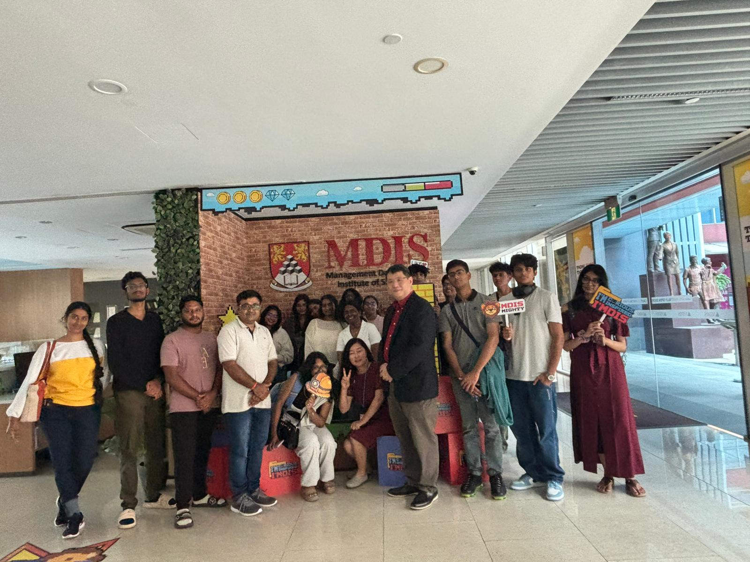
Day 1: Changi airport
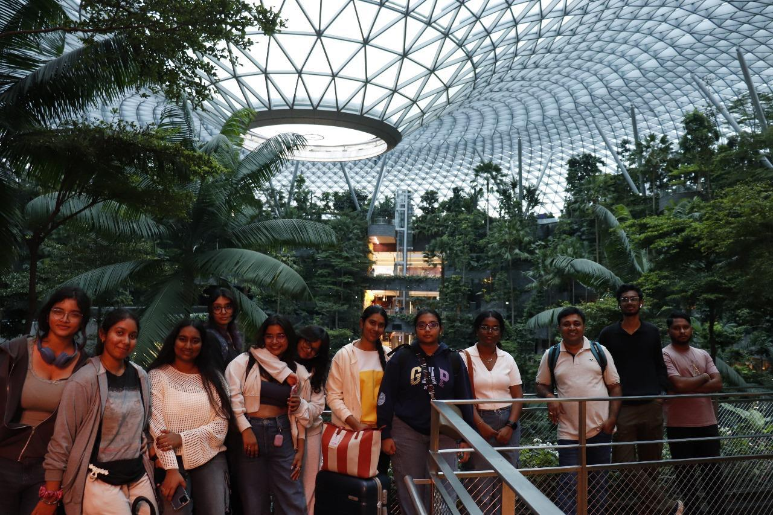
Day 2: Gardens by the bay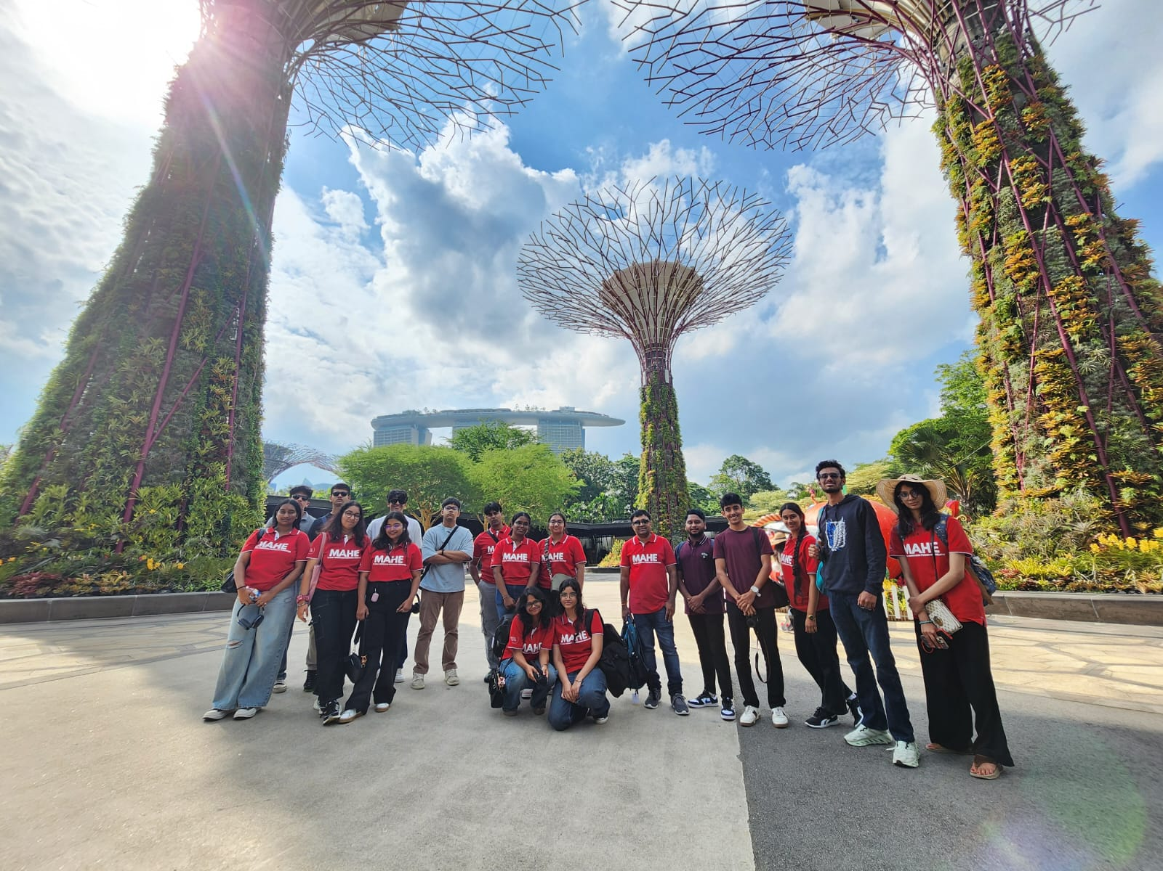
Day 1: Interactive session at MDIS
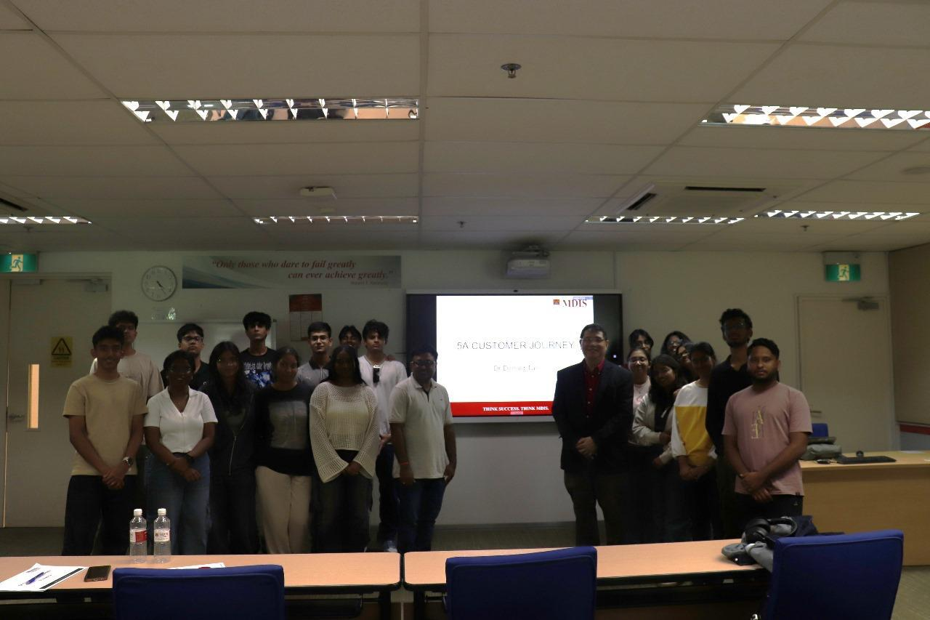
Day 2: Gardens by the bay
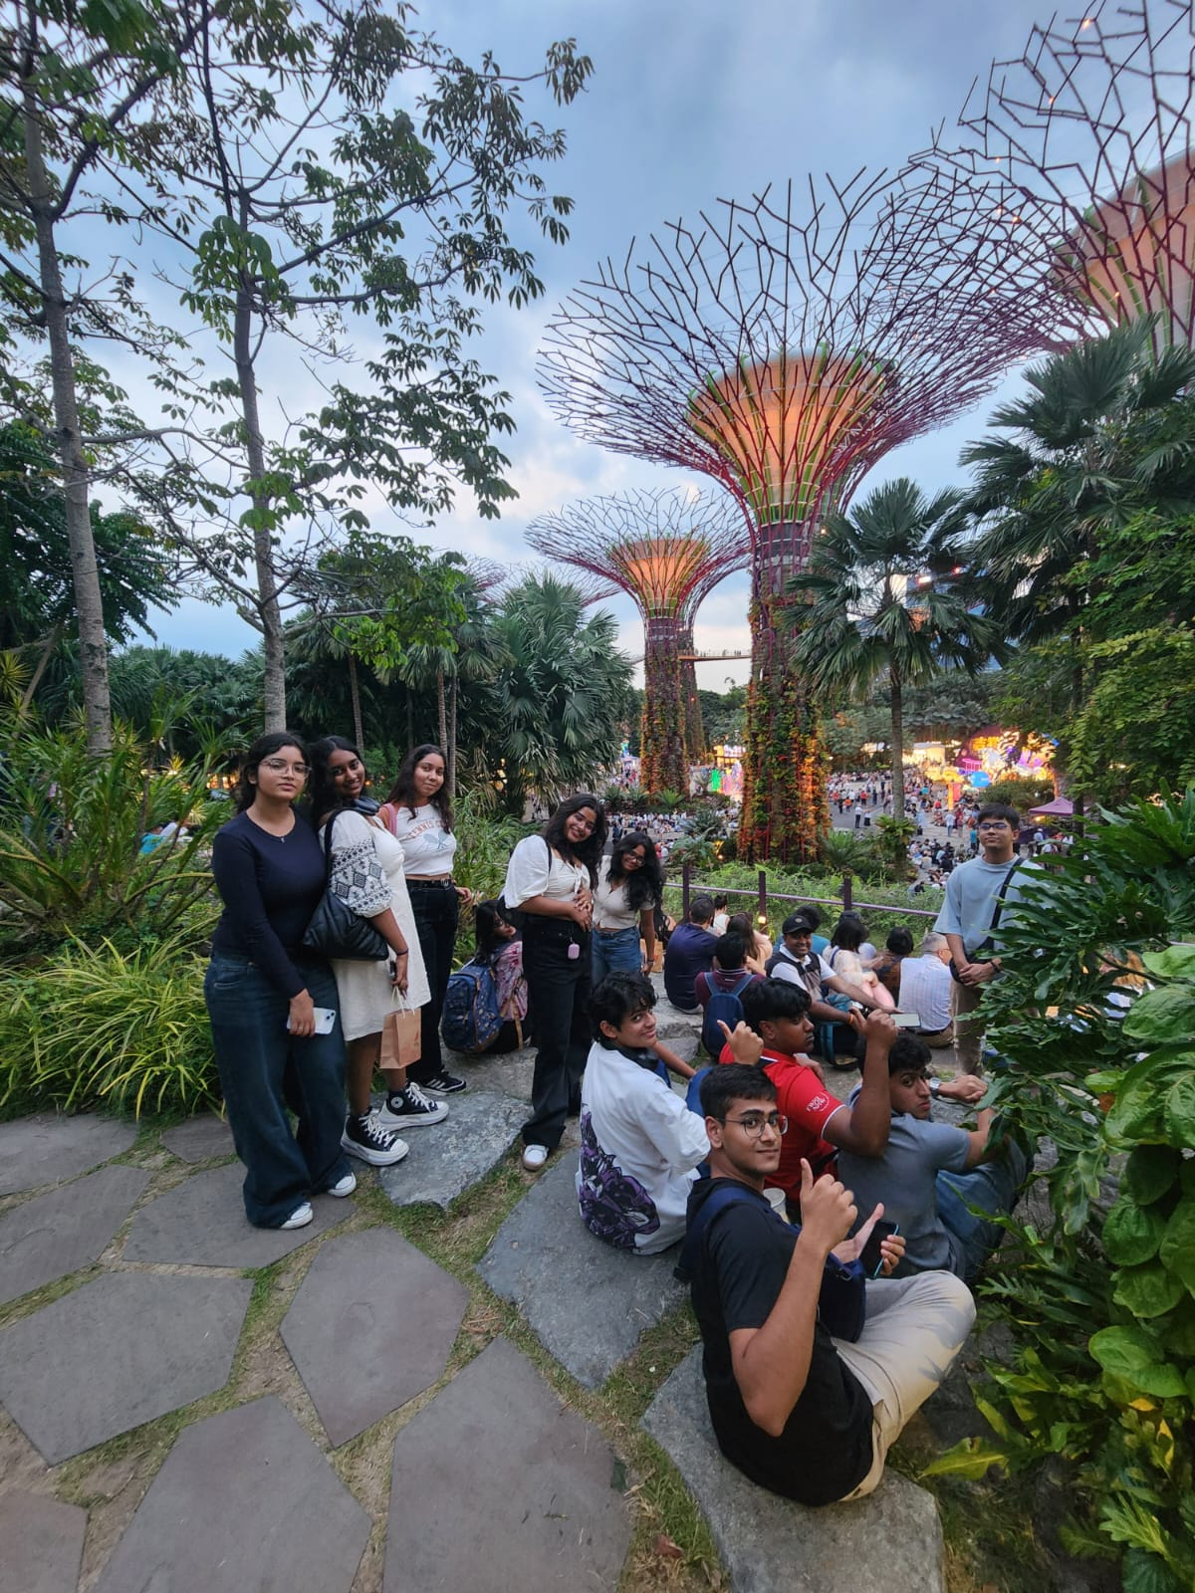
Urban redevelopment authority singapore
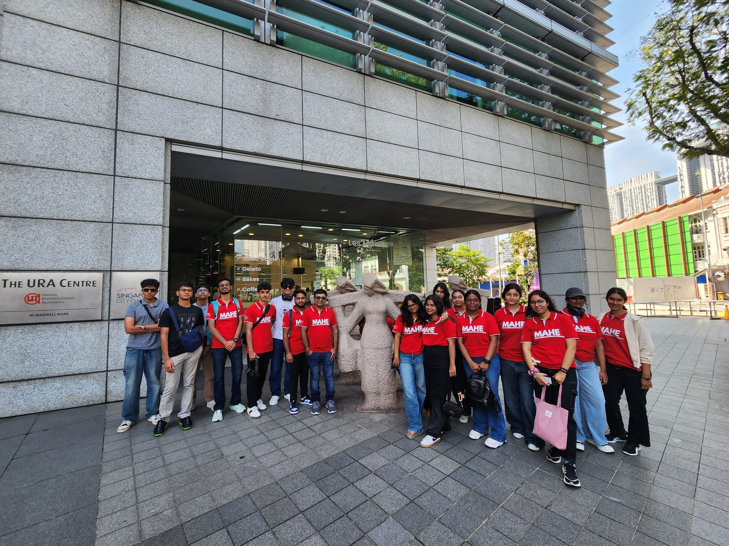
Terminal Changi airport
