

DEPARTMENT OF COMMERCE
REPORT ON “Pre-Placement Training”
31st Jan and 1st Feb 2025

Date: 31st Jan & 1st Feb 2025
Venue: AB4 208 Lecture Hall
Timings: 9:00 AM to 4:30 PM
The Department of Commerce organized a comprehensive pre-placement training session that covered resume writing, mock interviews, group discussions, digital skills, corporate communication, and more. This session was designed to give students practical insights and prepare them for future placement activities.

Speaker Profile:
Mr. Sridhar Kubasad, an accomplished Associate Vice President at ANZ, led the session. With over 15 years of experience in the banking sector, Mr. Kubasad holds expertise in Business Management, Machine Learning, Client Transactional Insights, and Data Intelligence. He is an alumnus of the prestigious IIM Ahmedabad, where he completed the Accelerated General Management Program.

Key Highlights of the Training Program –
Session 1: Skills Report 2024
The training program began with an insightful discussion on the Skills Report 2024, highlighting the top skills required in the current job market. The session covered:
- Men dominate roles in tech (AI, cybersecurity), finance, consulting, and supply chain management across major cities.
- Women are growing in HR, digital marketing, fintech, entrepreneurship, and STEM leadership roles.
- Hybrid work models & STEM initiatives are enabling more women to enter traditionally male-dominated fields like AI and EV.
- Emerging trends include women in sustainable tourism, fintech, and e-commerce startups, while men lead deep tech and consulting.
Session 2: Communication
The second session emphasized the importance of effective verbal and written communication. Key takeaways included:
- The impact of clear and concise messaging in professional settings.
- Public speaking and presentation skills for workplace success.
- Overcoming communication barriers.
- Role-playing exercises to practice workplace interactions.
Session 3: Email Etiquette
This session provided insights into formal email writing, including:
- Structuring a professional email.
- Dos and Don’ts of corporate email communication.
- Common mistakes and how to avoid them.
- Live examples and practical exercises on writing professional emails.
Session 4: Corporate Expectations
This interactive session covered:
- The workplace culture in corporate settings.
- Expectations from new employees.
- Professionalism, time management, and accountability.
- Adapting to organizational goals and values.
- A Q&A session with participants sharing their perspectives.
Session 5: Resume Building
A practical session on crafting an impactful resume, covering:
- Structuring a professional resume.
- Writing a compelling summary and achievements.
- Avoiding common mistakes.
- Participants were given a resume review exercise with personalized feedback.

Day 2: 1st February 2024
Session 6: Emotional Intelligence
The second day commenced with a session on Emotional Intelligence (EI), focusing on:
- Understanding self-awareness and self-regulation.
- Building empathy in workplace relationships.
- Managing stress and workplace conflicts effectively.
- A practical EI assessment and discussion on improving emotional resilience.
Session 7: Opportunities in Banking
A deep dive into career opportunities in the banking sector, including:
- Roles and responsibilities in banking and financial services.
- Emerging fintech trends and digital banking.
- Skills required for a successful career in banking.
- Guidance on internships and job applications.
Session 8: Mock Interviews & Group Discussions
The day concluded with mock interview sessions and group discussions, where students got hands-on experience in:
- One-on-one interviews with feedback on strengths and areas of improvement.
- Group discussion techniques and evaluation criteria.
- Overcoming nervousness and improving confidence.
- Real-time feedback from the resource person.

Session 9&10: Case Study
The final session involved a case study discussion, where participants:
- Worked in teams to analyze a real-world business problem.
- Applied critical thinking and problem-solving skills.
- Presented their findings and recommendations.
- Received feedback on their approach and decision-making process.

Conclusion & Feedback
The two-day pre-placement training program was highly interactive and beneficial for students. The resource person, Mr. Sridhar Kubasad, provided valuable insights and practical exposure to industry expectations. Participants gained confidence in interview skills, professional communication, and career readiness.
The event concluded with a vote of thanks from the organizers, expressing gratitude to the speaker and students for their active participation.

Session Feedback –

- Overall Satisfaction: The majority of students rated the training highly (5/5) across all parameters, expressing great appreciation for the detailed and well-structured sessions. Most students were very satisfied with the program.
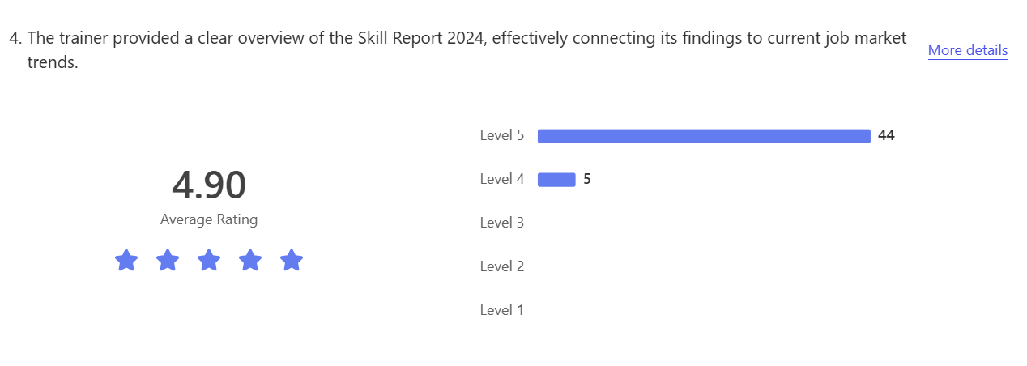
- Strengths: Students praised Sridhara Kubasad for his detailed explanations, engaging delivery, and real-world insights into corporate expectations. The training exceeded expectations for many, especially in areas of resume building, communication, and mock interviews.
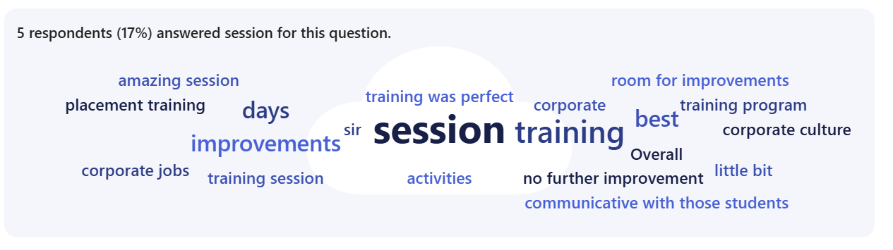
- Areas for Improvement: Some students suggested more flexible breaks, increased duration for mock interviews, additional case studies, and more interactive activities to engage quieter participants. A few also recommended adding physical activities to break the monotony.
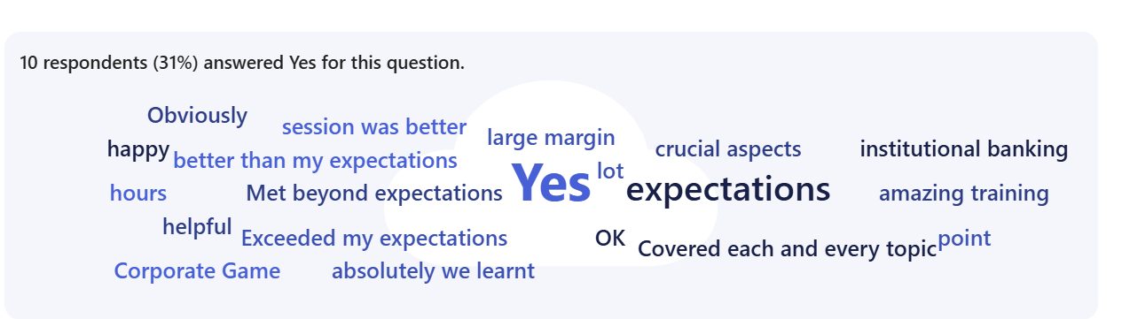
- Key Takeaways: The program was effective in preparing students for corporate careers, with practical skills, insights into industry expectations, and valuable interview experiences. Many expressed interest in more sessions in the future to further build on their learning.

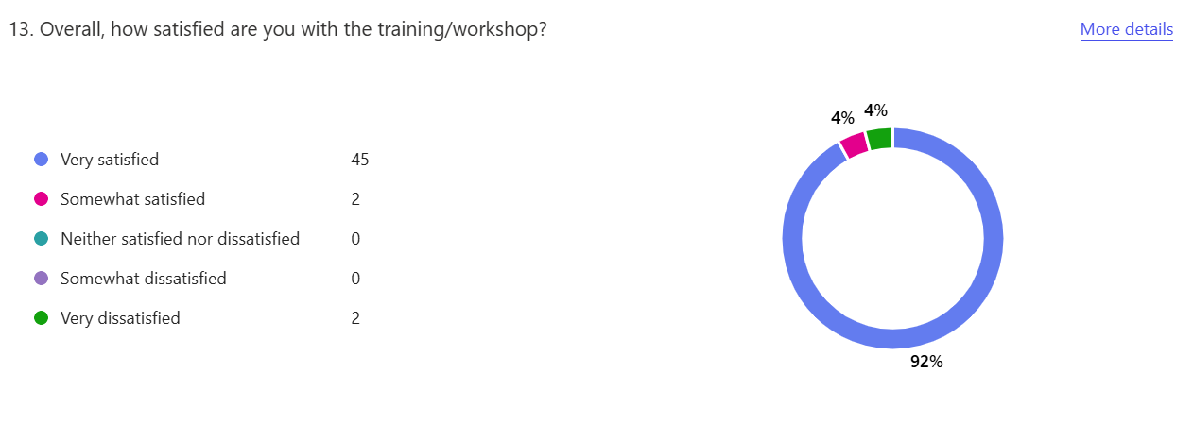

Brochure Attached

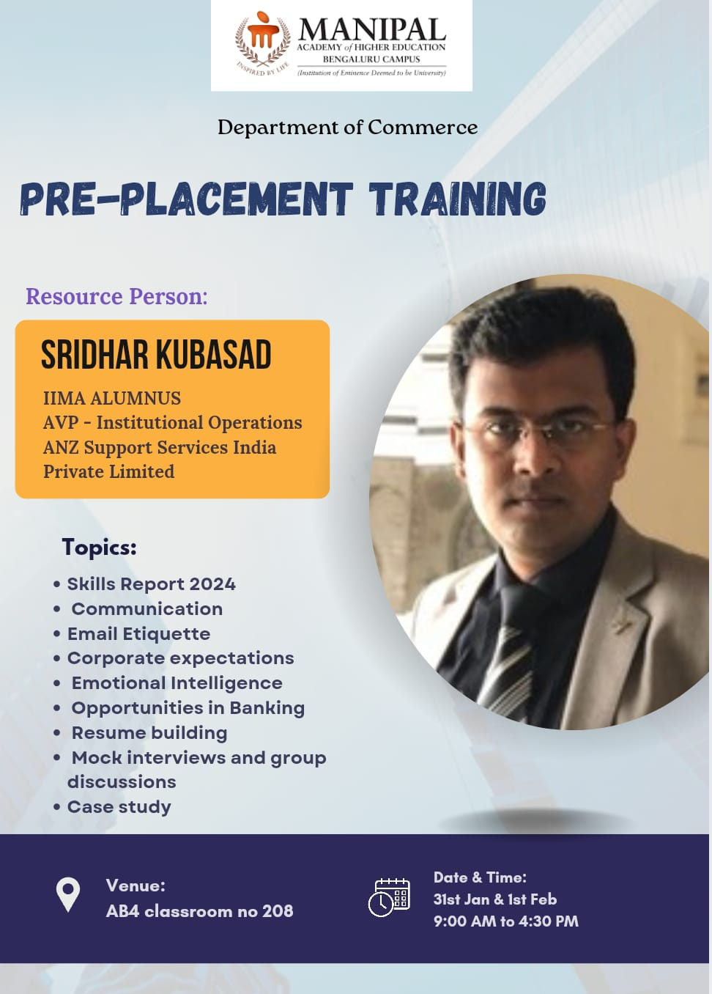
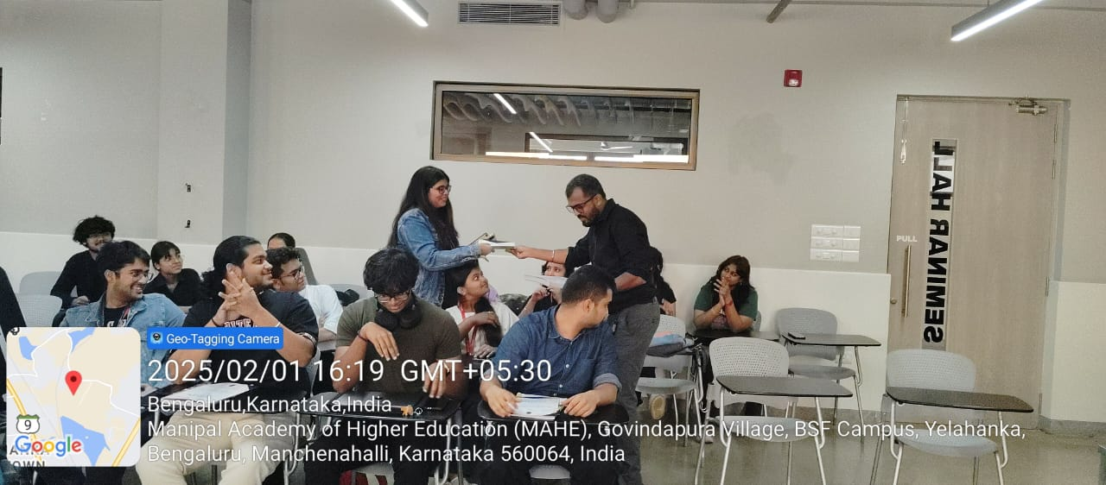
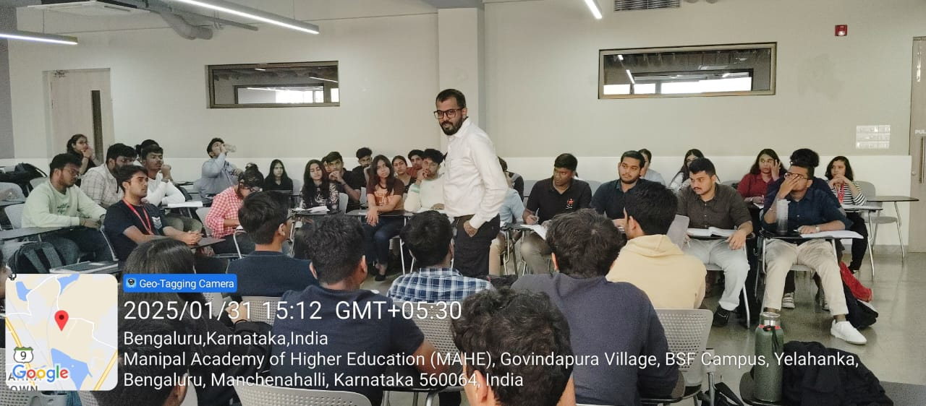
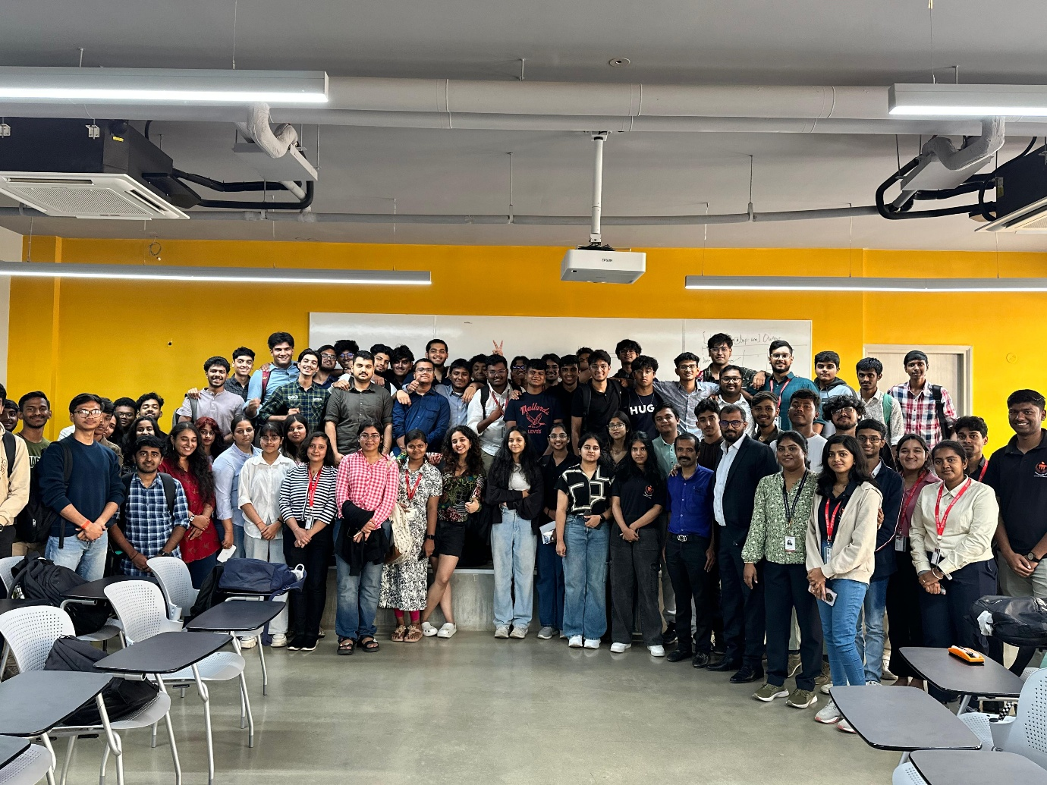

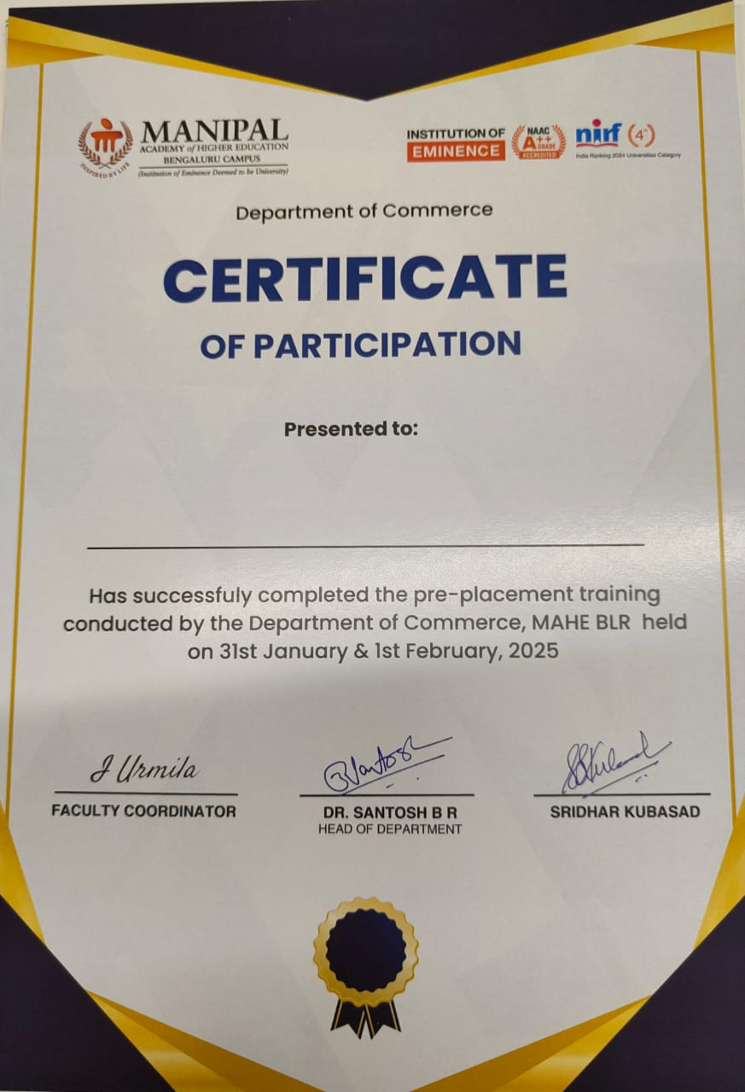

Attendance Sheet
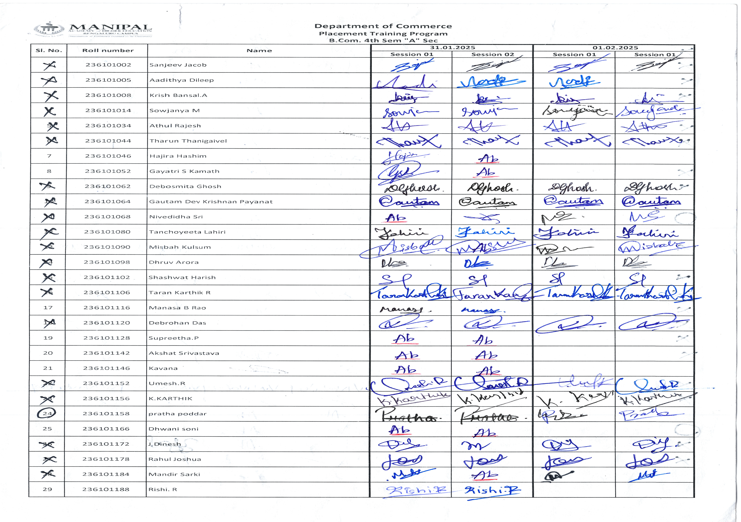
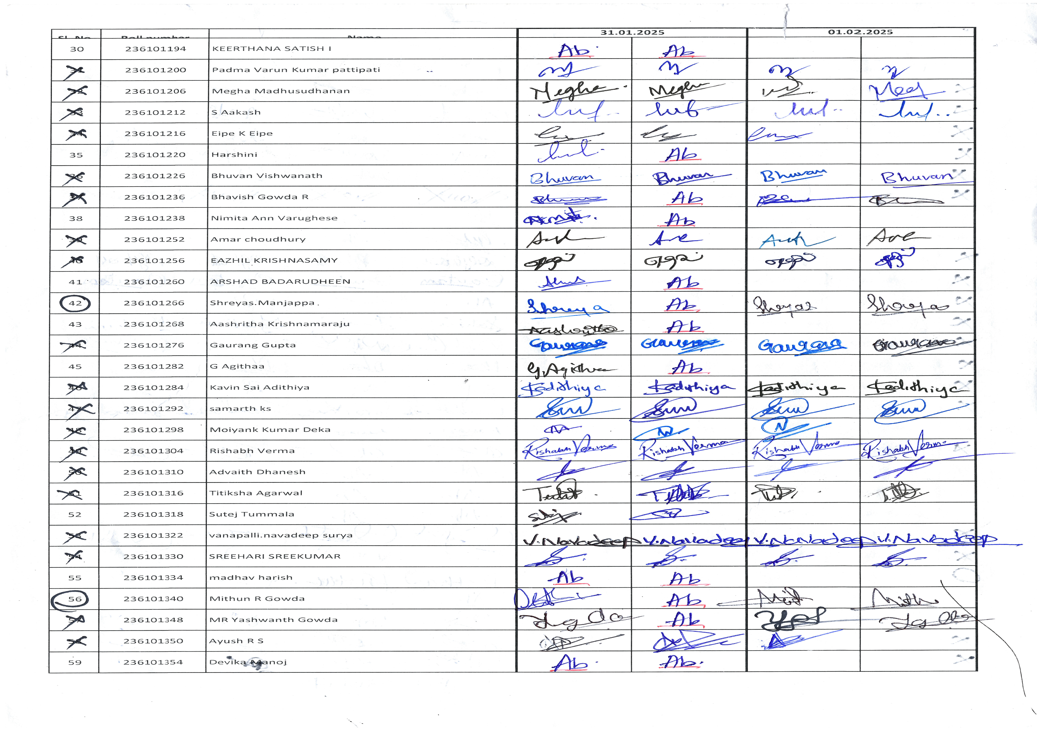

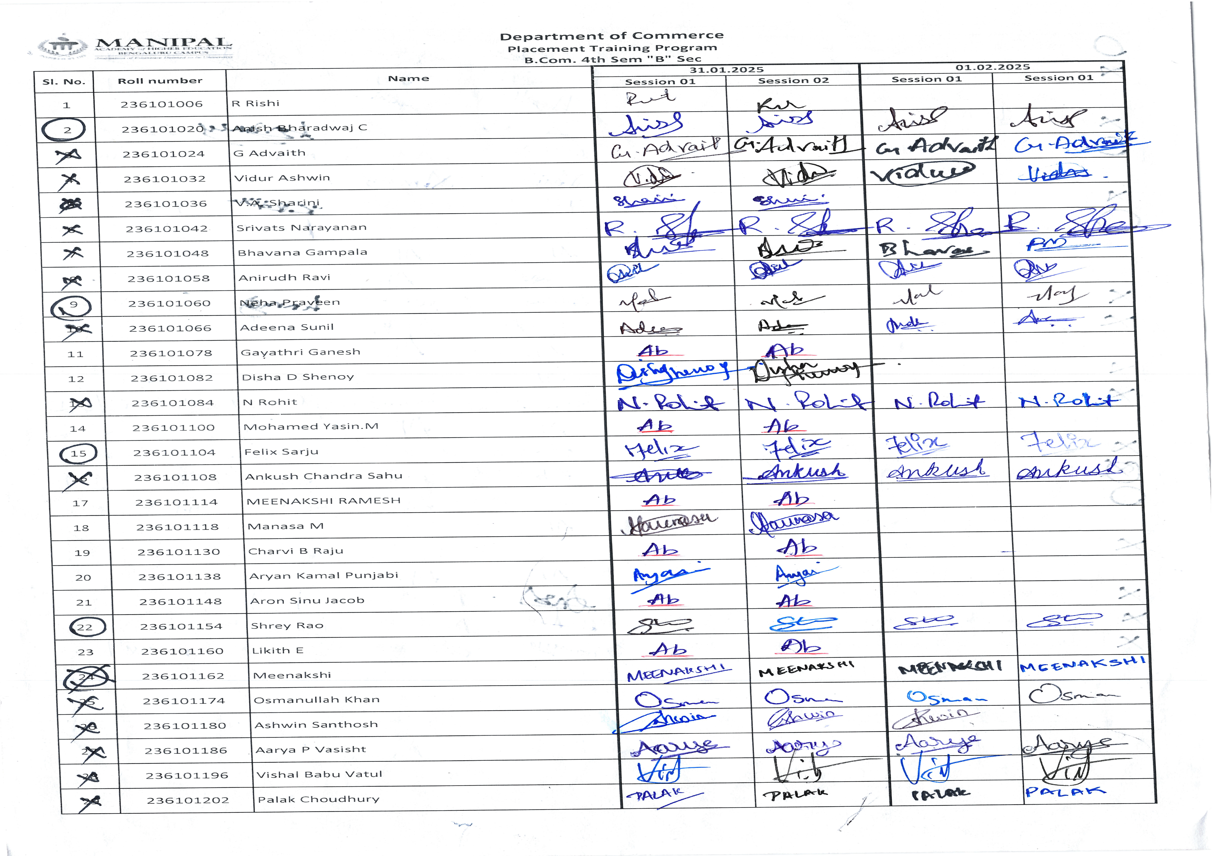

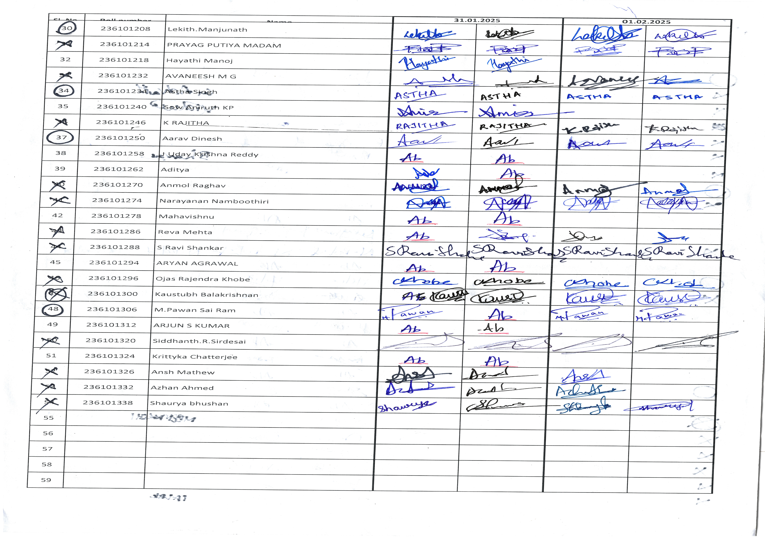
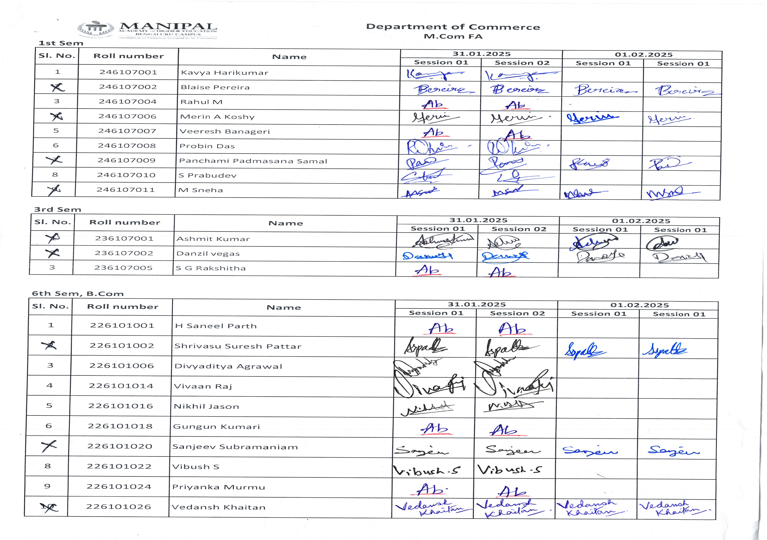
Dr. Urmila Itam Dr. B R Santosh
Event Co-Ordinator Head of the Department

