IQAC Training Session

Topic : An Interactive Session on SDG: Main Areas of Ranking MAHE Concentrates on

Date : 20th May 2024

Delivered by: Mr. Srikanth R. Gumaste, Data Analyst – IQAC, Manipal

Attendees: IQAC Team members of Bengaluru Campus & All IQAC coordinators from various Institutions/ Departments – MAHE, Bengaluru Campus

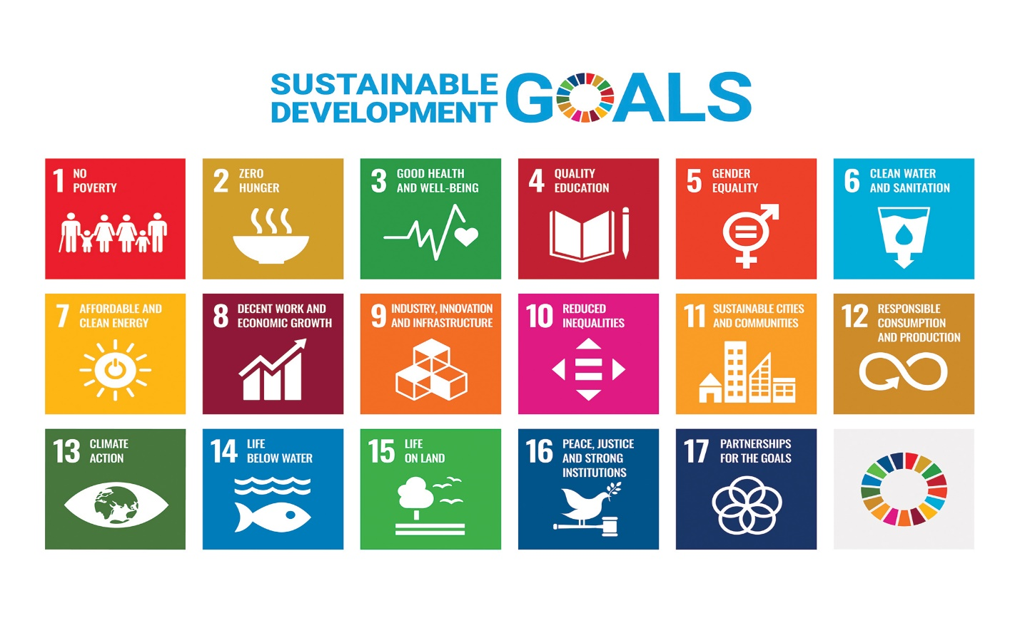

As rightly quoted by George Washington Carver "Education is the key to unlock the golden door of freedom." Manipal Academy of Higher Education popularly known as MAHE, also an Institution of Eminence has been ranked 25th in ‘Quality Education’ and 4th in ‘Gender Equality’ globally from the list of Sustainable Development Goals (SDG) developed by UN. This accomplishment has been the enormous hard work put in by the Institution which is now preparing itself to compete for all 17 SDG’s.

A session on SDG was very much the need of the hour at this juncture for the IQAC co – Ordinator’s at MAHE – Bengaluru Campus who are beginning to learn to map all events conducted at their respective Institution/ department to SDG. It was extremely glad for the IQAC team to invite Mr. Srikanth, Data Analyst of IQAC Team Manipal who on our request delivered a session on SDG and why University prepare to focus on achieving and improving their SDG ranks.

The session commenced by explaining all 17 SDG’s and what events can be conducted for each SDG by highlighting examples. The ‘how’ and ‘what ‘ data can be captured was well explained and an overwhelming response was witnessed in the floor as participants had an array of queries and inputs to add on to the presentation.

The session also had reference to research publications and projects which can be a part of parameters for achieving higher ranks. Thanks to Mr. Srikanth for providing an informative session as it was an eyeopener for all participants.

As we look forward for more such sessions, we are on a marathon run to capture and collate our event details in the hope of achieving more accolades for MAHE!

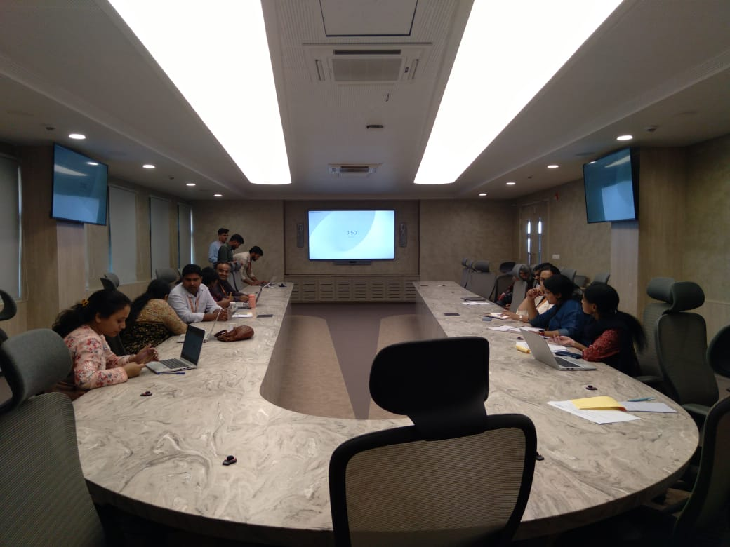 A glimpse of the Interactive Session

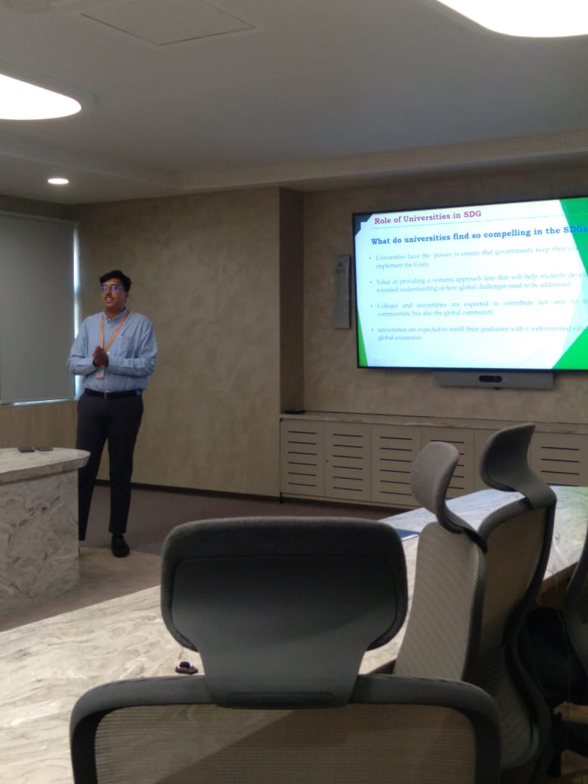 

Mr. Srikanth delivering the inputs on SDG during the session