**Manipal College of Dental Sciences, Manipal**

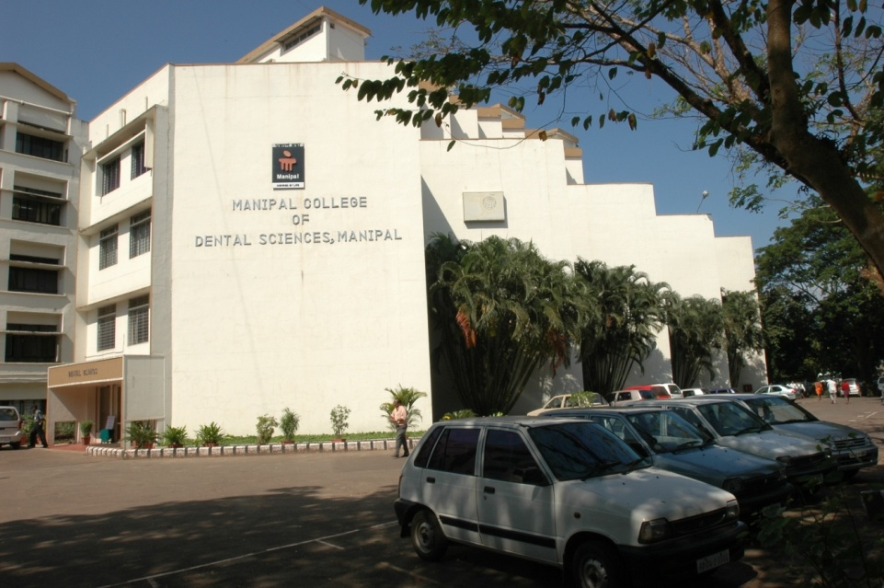

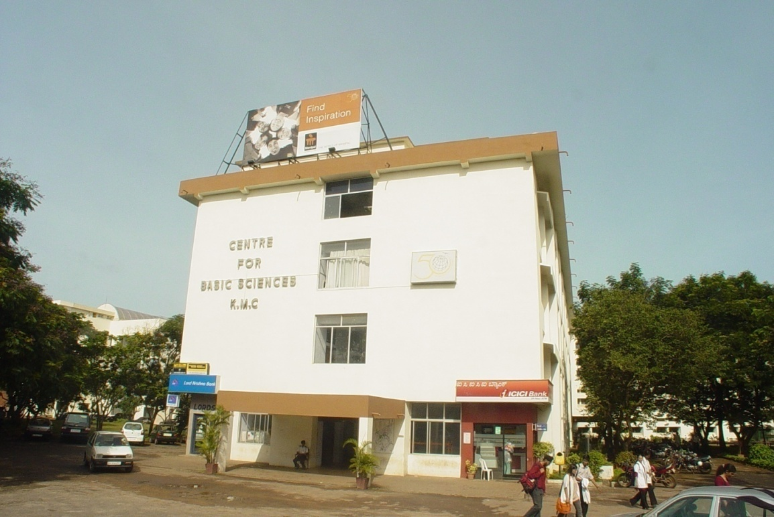

MCODS Manipal is currently situated in two buildings, the clinical wing housed adjacent to the Kasturba Hospital and the pre-clinical wing at the Centre for Basic Sciences.

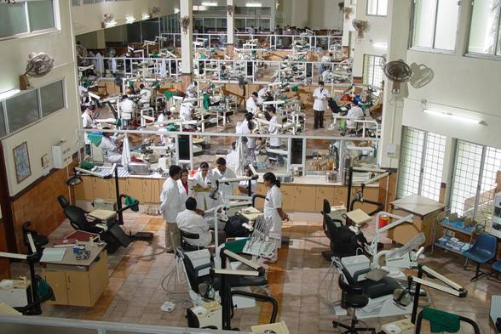

State of the art Dental clinics for UG and PG training Program

Phantom head laboratory for pre-clinical training, simulating the clinical Dental treatment

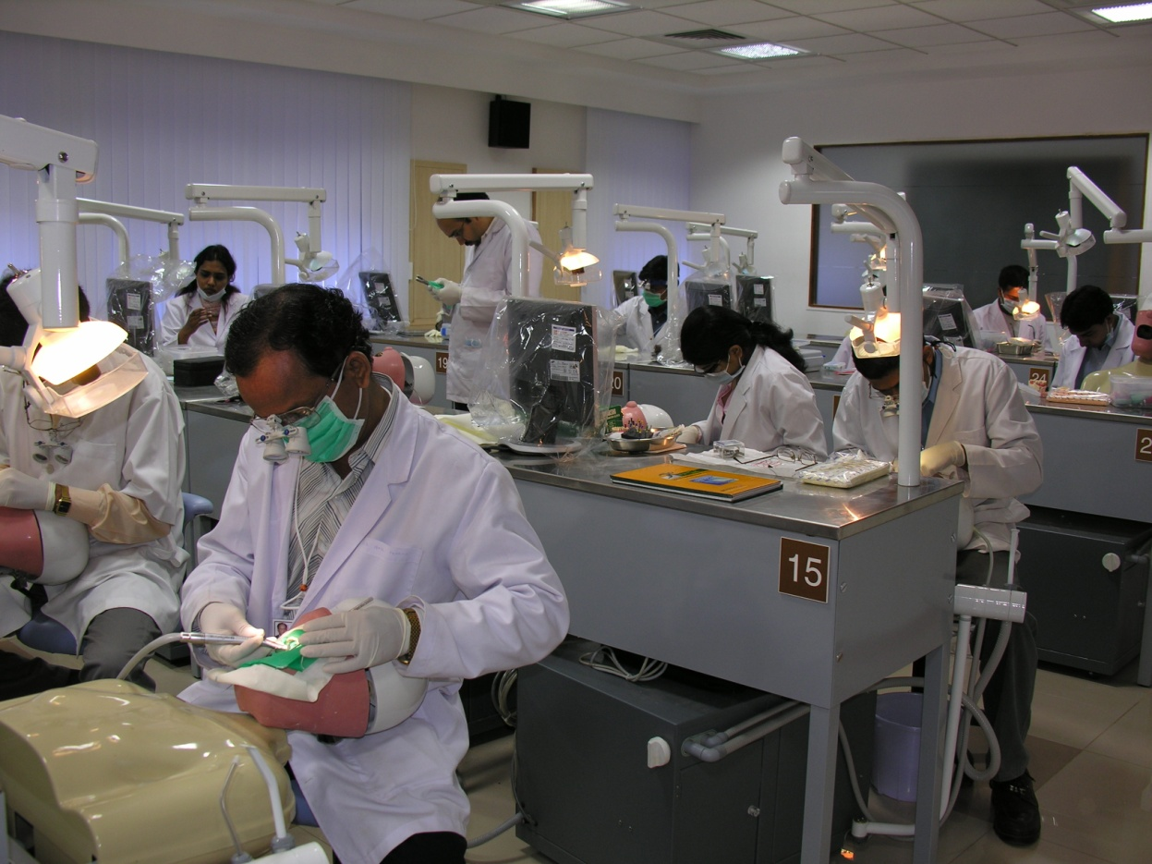

The Manipal College of Dental Sciences (MCODS), Manipal, formerly known as the College of Dental Surgery, is the first self-financing dental college in the private sector of India. Established in the year 1965, with an initial intake of 40 students that was later increased to 100 admissions in 1983, the BDS degree is recognized by DCI from 1970. MCODS, Manipal became a constituent college of Manipal Academy of Higher Education (MAHE) that was conferred the status of a deemed University by UGC in the year 1993.

The college has metamorphosed through time and stands tall, both nationally and internationally. , it has grown to be the top rated Dental college in the country, according to a survey by the magazine “Outlook” in June, 2009. This feat was repeated yet again in 2010 when MCODS Manipal was ranked first among the institutes providing dental education.

Intake Capacity:

B.D.S. (Bachelor of Dental Surgery) : 100

M.D.S.: (Approval status)

|  |  |
| --- | --- |
| Specialty | No of Seats |
| Oral Medicine and Radiology | 03 |
| Conservative Dentistry and Endodontics | 04 |
| Periodontology | 06 |
| Oral and Maxillofacial Surgery | 03 |
| Prosthodontics and Crown &Bridge | 04 |
| Paedodontics and Preventive dentistry | 03 |
| Orthodontics and DentofacialOrthopedics | 03 |
| Public Health Dentistry | 02 |
| Oral Pathology and Microbiology | 03 |

**Contact details**

Manipal College of Dental Sciences, Manipal

Madhav Nagar, Manipal

Pin - 576104

Karnataka, India

Phone: 91-820-2922340

Fax No: 91-820-2571966

E mail: office.cods@manipal.edu