Guest Talk on
Earth Observation Satellites and Application

Mechatronics Department arranged a talk on “Earth observation satellites and applications” on 31st July, 2019 by Dr P G Diwakar, distinguished scientist and director of earth science and disaster management, ISRO at Sir M V Seminar Hall, MIT Manipal.
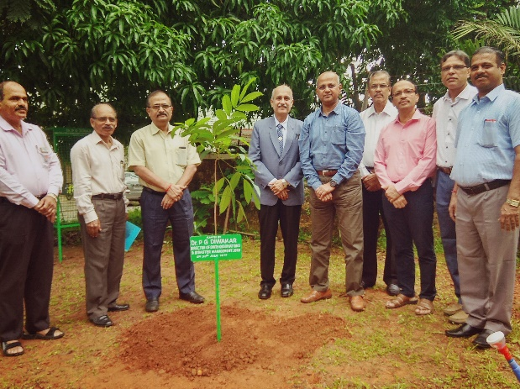
Dr P G Diwakar addressed students and faculty members and gave an overview of major projects carried out in the past 50 years in space research. He started by stating the ISRO’s vision to harness space technologies for National Development while pursuing space science research and planetary exploration and continued to provide some insight into various satellite launch vehicles that ISRO has carried out so far.

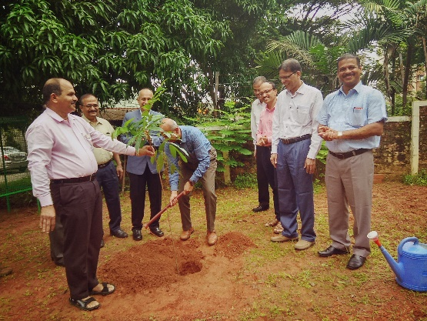
He talked extensively on several applications achieved using earth observation satellites such as geo-fencing, geo-tagging, identification of fish catchment areas for fisherman, crop management, forest changes, flood monitoring, road condition monitoring, etc.
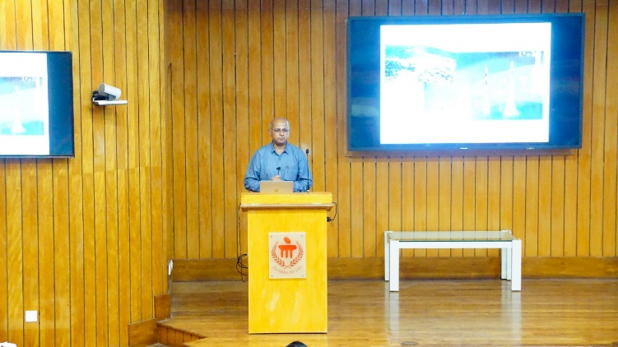
By stressing the Chandrayana-1, Chandrayana-2 and Mars Orbiter Mission (MOM), he gave a brief overview of on-going projects, and future projects. He mentioned that the images captured by the satellite are available in the ISRO website.

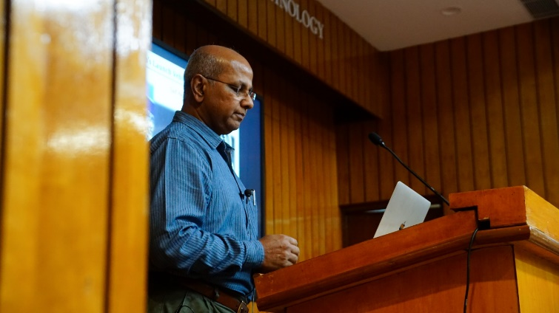
He pondered on Navigation Indian Constellation (NAVIC) which is technological contemporary of GPS with much better position and time accuracy. His work on generating 3D map of buildings and terrains through stereo vision was shown. He wished students to come up with innovation and assured the support of ISRO.
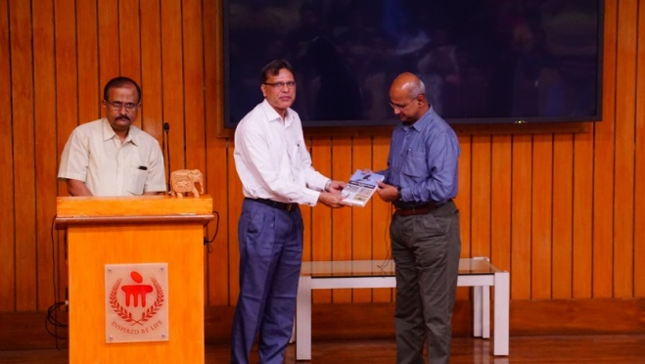
To name few upcoming project CARTOSAT which is a series of high resolution image capturing and processing is to enhance its capabilities from 60 cms to 25 cms resolution soon which again would be a record.

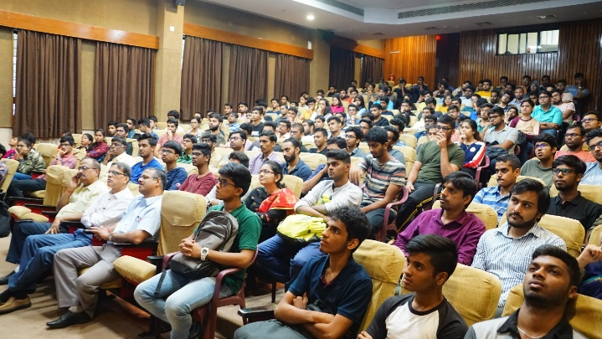
Finally, the speaker addressed the queries of students regarding the reusable launch vehicles, ISRO opportunities, man mission, private data availability to academia for research purpose. At the end, Joint director, Dr B H V Pai and HOD Dr. Chandrashekar Bhat gave a memento as a token of love and appreciation.
Dr Chandrashekar Bhat, Head Mechatronics Department welcomed and introduced the guest Dr. P G Diwakar to the audience.
About Speaker: Dr P G Diwakar, a Distinguished Scientist, Director of Earth Observations and Disaster Management, ISRO is a Doctorate in Participatory Geomatics from National Institute of Technology (NIT), Surathkal. He has been serving ISRO for the fast 34 years. He has held the various posts of Earth Observation Systems, Scientific Secretary, Deputy Director of National Remote Sensing Centre (NRSC), Hyderabad, Head – National Natural Resources Management System in ISRO, Bangalore. As a Team Leader, played key roles in delivering many important applications solutions. Dr. Diwakar is the recipient of many awards which include ISRO awards, national and international recognition for Innovative use of IT and geospatial technologies. He was conferred as “The Fellow of Indian Society of Remote Sensing”. He has more than 75 publications in National and International journals.
Date: 31-07-2019
Time: 9:45AM
Venue: Sir M V Seminar Hall
Speaker: Dr P G Diwakar
Director, Earth Observations and Disaster Management,
Indian Space Research Organization (ISRO), India
Topic: Earth Observation Satellites and Applications
Audience: Mechatronics Students (III, VII, PG)
Faculty members

