A Report of a Workshop On
“PC Based Automation Control Technology” by Beckhoff Systems

On the 21st of September, 2017, a workshop on “PC Based Automation Control Technology” was organized by the Department of Mechatronics Engineering and was delivered by, Mr. Ajay Pathak (Sr. Marketing Agent of Beckhoff) and Mr. Jitendrakumar Kataria (Managing Director Beckhoff Automation) with their assistant Mr. Shrishail at the Library Auditorium from 10 am onwards. Beckhoff is a German based automation technology company established in 1980. Beckhoff focuses on PC-based control technology with the segments Industrial PC, Embedded PC, fieldbus components, drive technology and automation software.
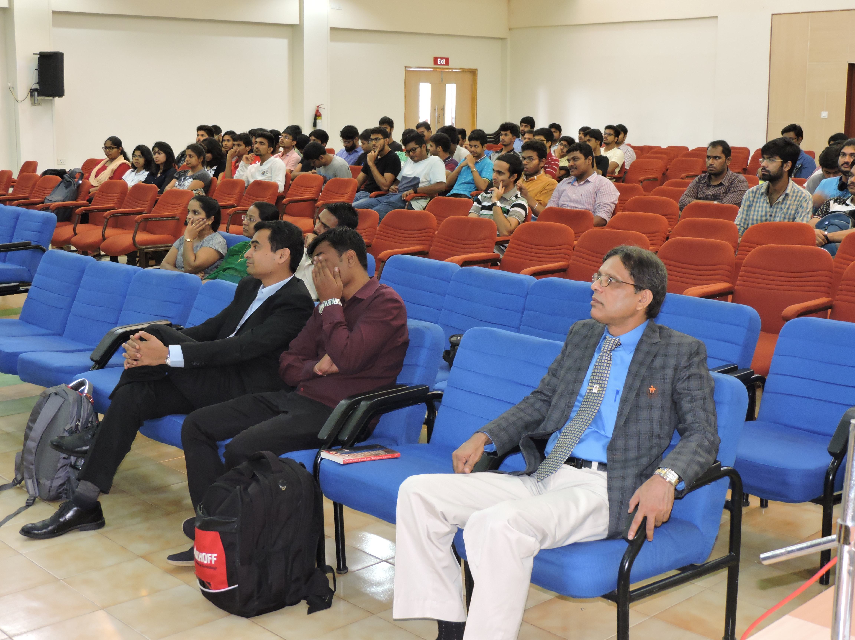
Audience for the talk by Mr. Ajay Phatak
The program started at 10 am with a warm welcome and introduction speech by Dr. Chandrashekhar Bhat, Head of the Department of Mechatronics Engineering, followed by the talk.
It was attended by B. Tech and M. Tech students as well as faculty members of various Engineering streams/ branches of MIT.
In the first session of the talk Mr. Ajay Phatak briefed us about the Beckhoff Company and its growth and achievements over a period of 30 years. He stressed on the fact that “automation can’t take place without communication and feedback” and how the Beckhoff company products play an important role when compared with other promising technologies.
In the second session, Mr. Jitendrakumar Kataria explained about how Beckhoff PC Automation system integrates PLC & HMI into one software on one CPU. Followed by elaborating the Significance of other communication protocols, the speaker specifically emphasized about EtherCAT (Ethernet for Control Automation Technology), which is world’s fastest real-time Ethernet field bus system. EtherCAT can handle 10000 distributed Inputs and outputs in cycle time of 30 micro seconds with virtually unlimited network expansion.
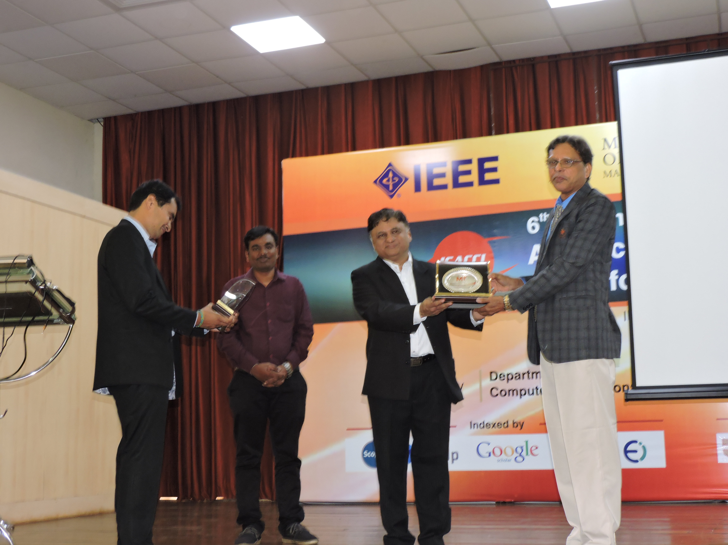
Mr. Ajay Phatak being presented with a memento by Dr. Chandrashekhar Bhat.
Throwing light on the fact that “mechanical/ electronics based hardware, control systems- cannot be changed in a design, but the software can be changed with ease”, hence TWinCAT software (T-Windows based Control Automation Technology) has been introduced to accommodate the changes in logic. TWinCAT can run in background for acquiring data and decision making, with user defined tools like Labview, SCADA as front end interfacing. TwinCAT software works only on windows based visual studio and not on LINUX. Windows does not work real time hence they are customized by changing the kernel and converted to real time.
The talk also covered the various topics on Industry 4.0 smart factories how physical system cooperate and communicate in run time with each other and humans. The factory of the future will be more horizontally and vertically connected, implemented in a more cost-effective manner with a machine-level controller by using a human-machine interface (HMI) for moving information to and from other areas of the company as needed. Industry 4.0 facilitates greater innovation for the manufacturing automation using advanced automation engineering to improve integration as well as design over the product lifecycle.
The newest technology in the current day scenario being the integration of ‘Automation technology’ and ‘Information technology’. The application areas using this emerging trends with PC based automation technologies touch many industries ranging from Manufacturing, energy, scientific automation, remote access, robotics, semiconductor manufacturing, medical engineering and many more
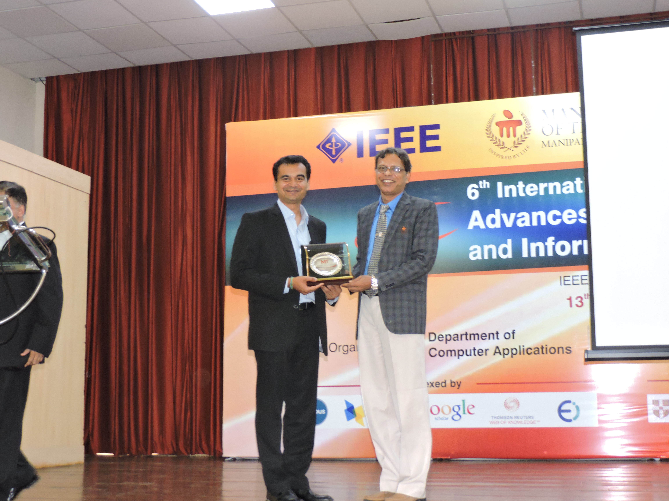
Mr. Jitendrakumar Kataria being presented with a memento by Dr. Chandrashekhar Bhat.
In the third session Mr. Shrishail demonstrated the velocity control, motion control and position control of the drives using TWinCAT software in the Robotics Lab of the Mechatronics Engineering department.
At the end students were invited to try their hands-on the demo & practical testing. They reciprocated with great enthusiasm in handling Beckhoff’s TWinCAT software where they programmed using ladder logic.
The entire day was fruitfully spent understanding the importance of communication in the forthcoming revolution of industrial automation. A bold step was taken by the Department of Mechatronics Engineering at MIT to equip its students with the latest communication hardware and software in the area of industrial automation by the signing of an MoU with Beckhoff Systems Pvt. Ltd.

