A Report on Diamond Jubilee Lecture Series a guest lecture on “Micro-Electro-Mechanical-Systems (MEMS)” was organized by Department of Mechatronics Engineering

As a part of Diamond Jubilee Lecture Series a guest lecture on “Micro-Electro-Mechanical-Systems (MEMS)” by Dr.Hithesh Kumar Gatty was organized by Department of Mechatronics Engineering on 29th July 2017.

Dr. Hithesh Kumar Gatty is a recipient of scholarship for 100 young engineer and was selected to carry out research at Advanced Research Centre of Electronic systems in Italy. He also worked in IMEC, Belgium on MEMS and has a deep understanding of Wafer-level MEMS fabrication. He obtained his doctoral degree from KTH Royal Institute of Technology, Sweden with a thesis in MEMS-based Amperometric sensor that is applicable for diagnosis and monitoring of asthma.
He is currently a post-doctoral research fellow at Uppsala University, Uppsala, SWEDEN. His main interest lies in MEMS, understanding various sensing principles and sensor fabrication in order to realize a miniaturized sensor. He has competency in sensor development based on novel materials applicable for medical technology industry.

The program started at 9 am with a warm welcome and guest introduction by Mrs.Maithri.M, Assistant Professor, Department of Mechatronics Engineering. The audience comprises of B.tech and M.tech students as well as faculty members of the department.

Dr.Gatty lecture was greatly focused on MEMS in the domain of Mechatronics. He started with discussing about the working principle of different sensors and their wide range applications. And then he explained about integrated amperometric gas sensor.

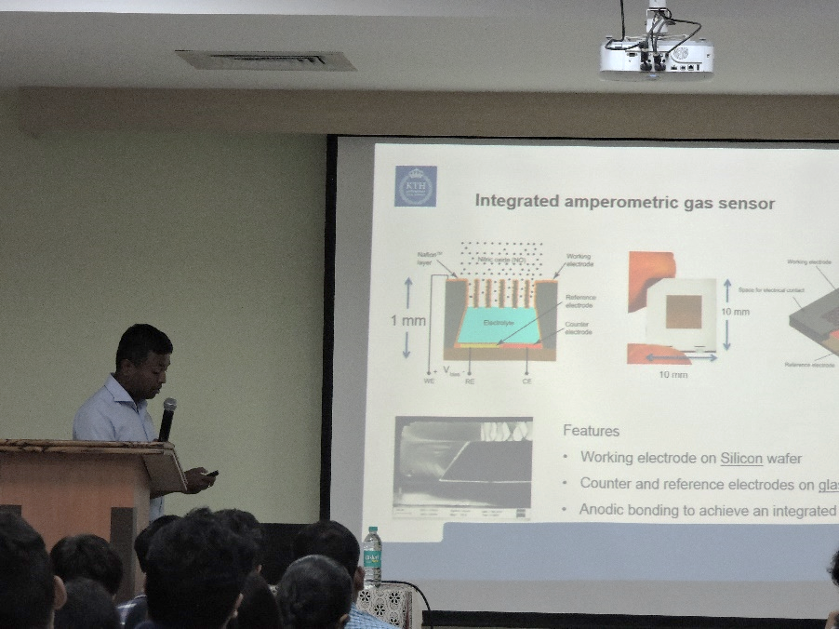

Dr.Hithesh Kumar Gatty explaining about Amperometric gas sensor
The talk continued with the discussion on the sensor design concept, importance of sensor miniaturisation, and design considerations to be taken in account of sensor design. He also discussed about the Sensor assembly for Miniaturized NO sensor and charterization of the sensors.

As the talk was proceeded he explained the technical advancement in the field of sensors and also stressed on the relevance and advantages of mems technology for sensors. He discussed about MEMS Accelerometer, an overview of pros and cons of an electrical accelerometer realised using MEMS over the conventional one.

He shared his practical experiences at various labs where he had done work related to mems. Towards the end of the talk he gave a list various project options to students in the field of sensors to take up to improve their practical skills.
The students showed great enthusiasm during question and answer session. With a great curiosity student asked a lot of questions, especially about life cycle of a MEMS device, costs in a trial, limitations etc. Dr. Gatty has answered the queries with equal enthusiasm. After the formal talk, the speaker interacted with many students in person and guided them for their projects, internships and future aspects.
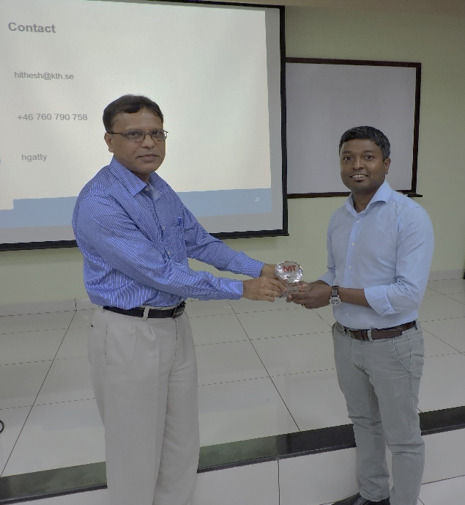
Dr.Chandrashekar Bhat presenting a memento to the speaker
As a token of gratitude, Dr. Chandrashekar Bhat, Head of Department of Mechatronics Engineering presented a Diamond Jubilee memento to our beloved guest Dr. Hitesh Gatty. The Talk concluded with a vote of thanks by Mrs. Akshatha Rakesh Pai. The program was a great success and everyone felt delighted and motivated toward research in MEMS in Mechatronics.

